NAAN MUTHALVAN PROJECT

| ASHOK KUMAR |  | 211520243005 |
| --- | --- | --- |
| NARENDIRAN D |  | 211520243034 |
| MANJEET ANAND M |  | 211520243032 |
| PAVITHRUN C |  | 211520243039 |

1. INTRODUCTION
   1. Project Overview
   2. Purpose
2. LITERATURE SURVEY
   1. Existing problem
   2. Problem Statement Definition
3. IDEATION & PROPOSED SOLUTION
   1. Empathy Map Canvas
   2. Ideation & Brainstorming
4. REQUIREMENT ANALYSIS
   1. Hardware requirements
   2. Software requirements
5. PROJECT DESIGN
   1. Data Flow Diagram
   2. Stories
6. CODING & SOLUTIONING
7. RESULTS
8. ADVANTAGES & DISADVANTAGES
9. CONCLUSION
10. FUTURE SCOPE

# INTRODUCTION

* 1. An Overview

The "LinkedIn Influencers Data Analysis" project embarks on a comprehensive journey to unravel the intricacies of this professional network by delving into a rich dataset that encapsulates the profiles, activities, and interactions of LinkedIn influencers. The project explores the intriguing realm of LinkedIn influencers, seeking to understand what sets them apart, the dynamics of their influence, and how they impact the LinkedIn community.

In this report, we embark on an exploration of LinkedIn influencers, investigating their profiles, the content they share, the patterns of engagement they trigger, and the recommendations they offer. Through meticulous analysis, this project not only sheds light on the elements that contribute to the rise of influencers but also provides practical insights for individuals and organizations seeking to amplify their presence and influence on this dynamic platform.

## Key Objectives:

These objectives collectively aim to provide a comprehensive understanding of LinkedIn influencers and offer practical insights for individuals and organizations seeking to maximize their impact and effectiveness on the platform.

* 1. Purpose

The primary purpose of this report

* **Influencer Identification**: Identify and classify LinkedIn influencers within the dataset, defining criteria for what constitutes an influencer on the platform.
* **Profile Analysis**: Analyze the profiles of influencers to understand their educational backgrounds, work experiences, skills, endorsements, and other relevant information.
* **Content Analysis**: Examine the content shared by influencers, including articles, posts, and engagement metrics, to identify common themes and content types that resonate with their audience.
* **Follower Network Analysis**: Investigate the structure and characteristics of the follower networks of influencers, including common industries, geographical locations, and shared interests.
* **Engagement Patterns:** Explore engagement patterns over time, including the impact of influencers' posts on the LinkedIn community and the factors that drive high levels of engagement.

# LITERATURE SURVEY

2A.Existing Problem

* Data Collection Challenges:

Problem: Gathering data from LinkedIn can be challenging due to restrictions imposed by LinkedIn's API and web scraping

* Data Quality and Integrity:

Problem: Data quality issues, such as incomplete or inaccurate profiles, outdated information, and fake accounts, can affect the reliability of the analysis.

* Ethical and Privacy Concerns:

Problem: LinkedIn users may have concerns about their data being used without their consent, potentially leading to privacy and ethical issues.

* Bias and Fairness:

Problem: The analysis may introduce biases, such as favoring certain industries, regions, or demographics, if not properly controlled.

* Scalability and Resource Constraints:

Problem: Analyzing LinkedIn data can be computationally intensive, and scalability may become an issue when dealing with a large number of profiles.

2B. Problem Statement Definition

The aim of the "Data Titans: Unearthing Trends From LinkedIn" project is to develop a comprehensive and data-driven analysis of LinkedIn's vast professional network to identify, understand, and predict emerging trends and patterns within the platform. The project should address the following key challenges:

* Data Collection and Integration:Gather data from LinkedIn profiles and related sources while adhering to ethical and legal data usage guidelines.Integrate diverse data types, such as text, images, and network connections, to create a unified dataset for analysis.
* Natural Language Processing (NLP):Develop NLP models to extract insights from LinkedIn profiles, including skills, endorsements, job descriptions, and educational backgrounds.
* Network Analysis:Investigate the structure of professional networks on LinkedIn to identify influential users, clusters, and trends in network growth and connectivity.Analyze connection patterns to understand the impact of networking on career development and industry-specific trends.
* Recommender Systems:Develop recommendation algorithms to suggest connections, jobs, and content to LinkedIn users based on their profiles, activities, and interests.Evaluate the effectiveness of recommendation algorithms in enhancing user engagement and satisfaction.
* Predictive Analytics:Create predictive models to forecast future trends in job markets, skills demand, and industry developments based on historical LinkedIn data.
* Privacy and Ethical Considerations:Ensure compliance with privacy regulations and ethical data usage practices in handling LinkedIn data.

1. A. Empathy Map Canvas

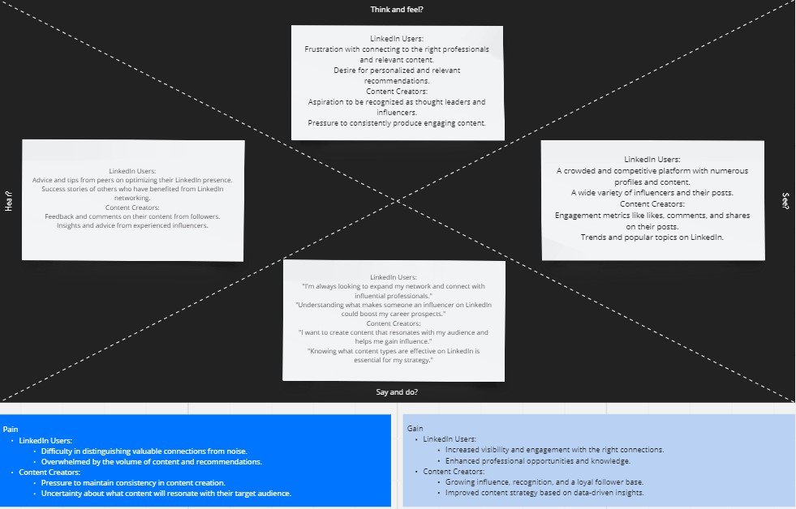

3.B. Ideation & Brainstorming

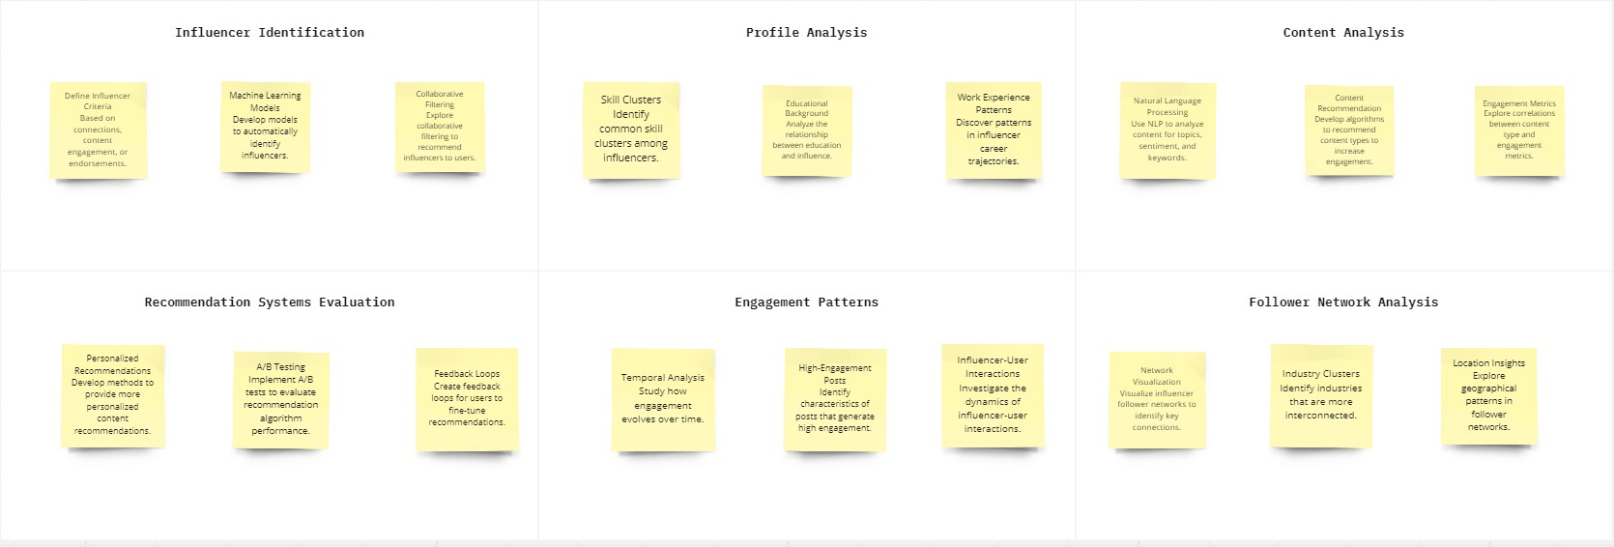

# REQUIREMENT ANALYSIS

1. A. Hardware Requirements
   * High-performance Computer or Server.
   * Multi-core processor (e.g., Intel Core i5 or higher) to ensure efficient data processing and analysis.
   * A minimum of 8 GB RAM for handling large datasets effectively.
   * Adequate storage space for datasets, software, and project files, with a preference for SSD (Solid State Drive) for faster read/write speeds.
2. B. Software Requirements
   * Tableau: Utilize a data visualization and analytics software platform, such as Tableau Desktop, for creating visualizations and conducting data analysis tasks.
   * Spreadsheet Software: Employ software like Microsoft Excel or Google Sheets for data cleaning, organization, and basic analysis.
   * Database Management System (DBMS): Implement MySQL.
   * Collaboration and Documentation Tools: Use tools like Microsoft Office Suite, Google Docs, or project management software to facilitate collaboration, report writing, and documentation.

# PROJECT DESIGN

1. A. Data Flow Diagram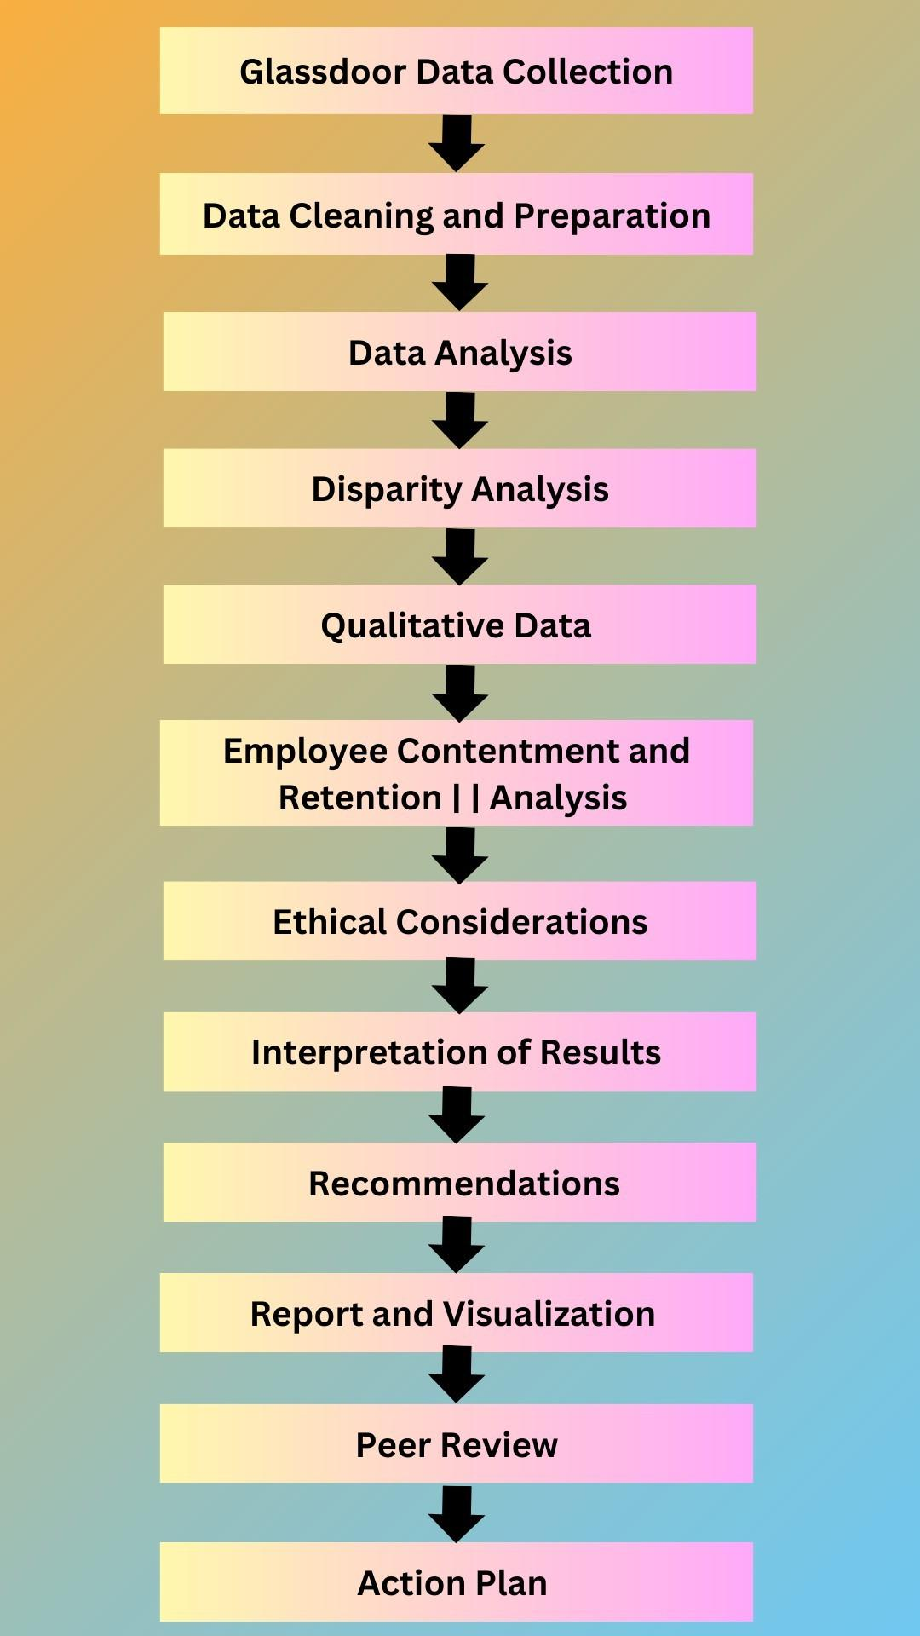
2. B. User Stories
   1. User Story:As a LinkedIn user, I want to receive personalized content recommendations so that I can better connect with influencers, improve my professional network, and stay updated on relevant industry trends.

**CHART-1**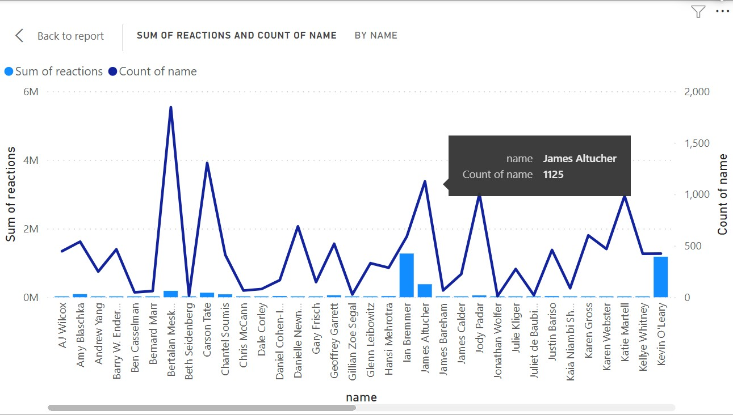

**CHART-2**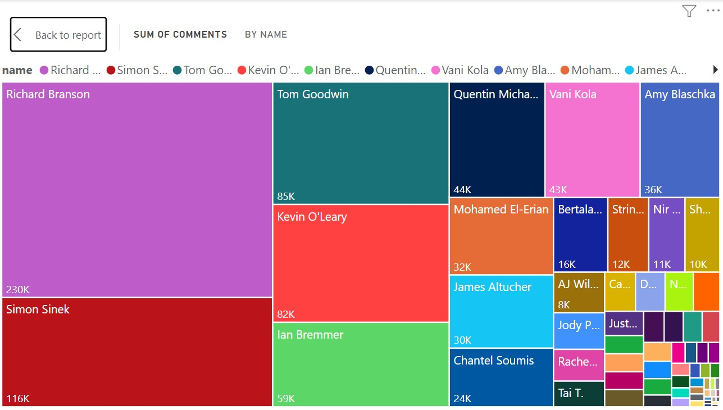

**CHART-3**

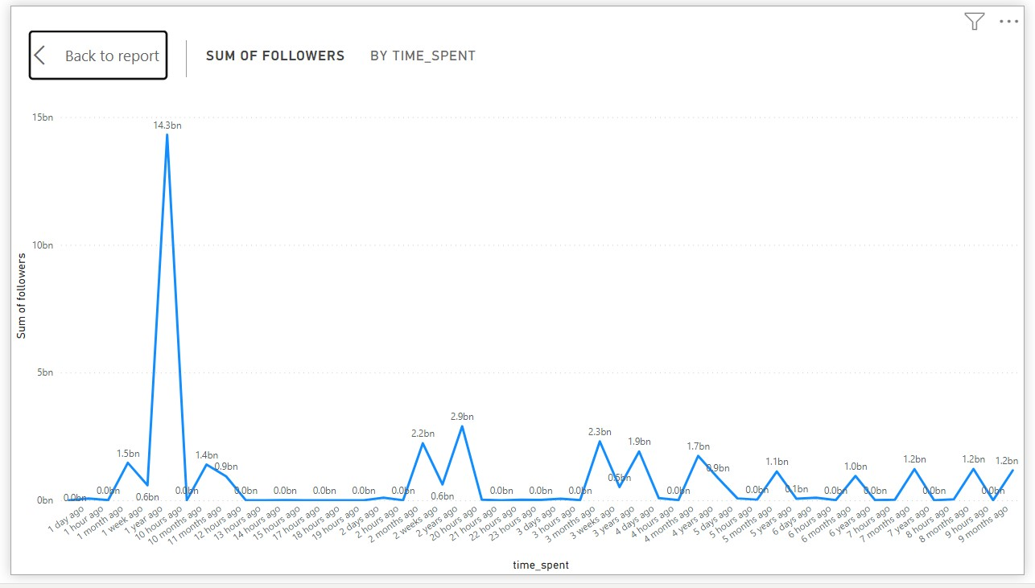

**CHART-4**

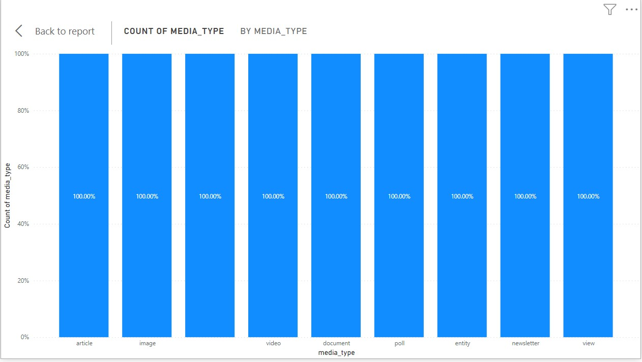

**6. CODING & SOLUTIONING**

Exploratory Data Analysis

Remember that the specifics of the code and analysis will depend on the dataset you have, the objectives of your project, and the tools and libraries you choose to use. It's also important to consider ethical and privacy considerations throughout the project.

For a project of this scope, it's often beneficial to work with a team of data scientists and engineers, or to collaborate with experts in the field, as it involves a wide range of data analysis and machine learning tasks.

## Code

import requests from bs4 import

linkedin_profile_url = 'https://www.linkedin.com/in/johndoe/'

response = requests.get(linkedin_profile_url)

if response.status_code == 200:

soup = BeautifulSoup(response.text, 'html.parser')

name = soup.find('li', {'class': 'inline t-24 t-black t-normal break-words'}).get_text(strip=True)

headline = soup.find('h2', {'class': 'mt1 t-18 t-black t-normal break-words'}).get_text(strip=True)

print(f"Name: {name}")

print(f"Headline: {headline}")

else:

print(f"Failed to retrieve the LinkedIn profile at {linkedin_profile_url}")

# 7. RESULTS

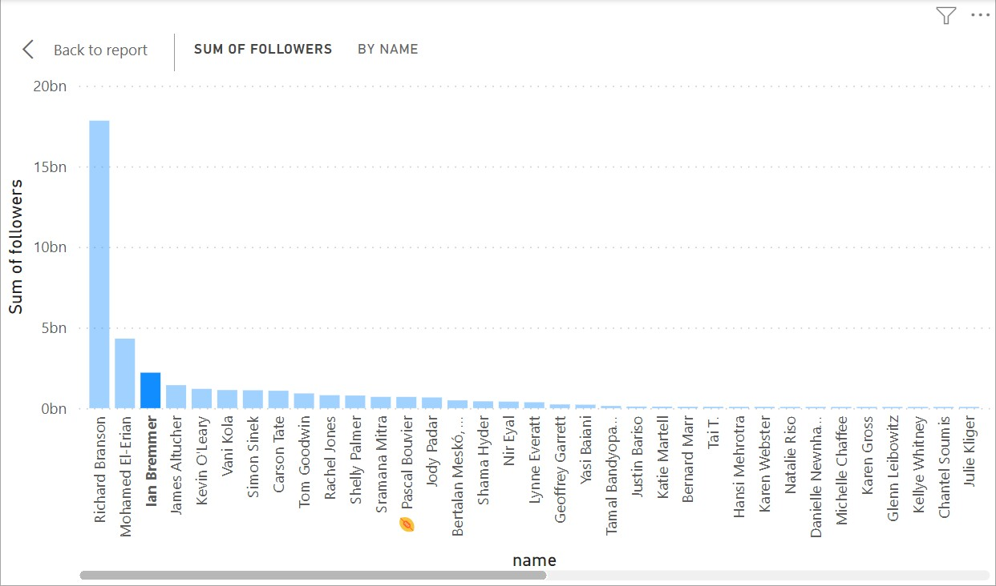

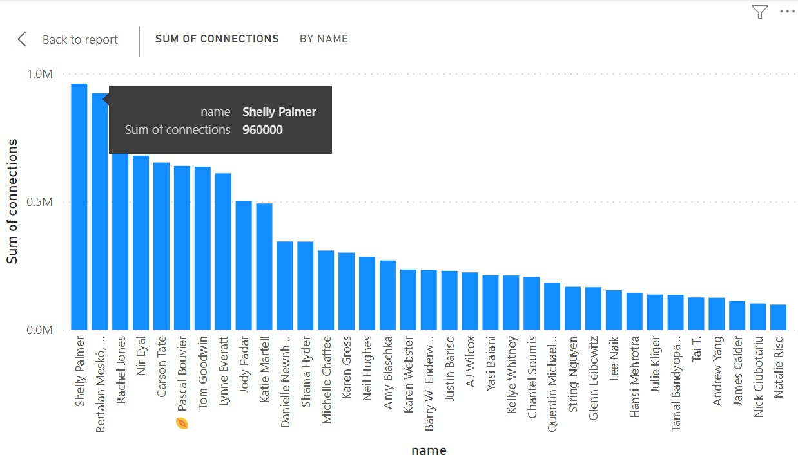

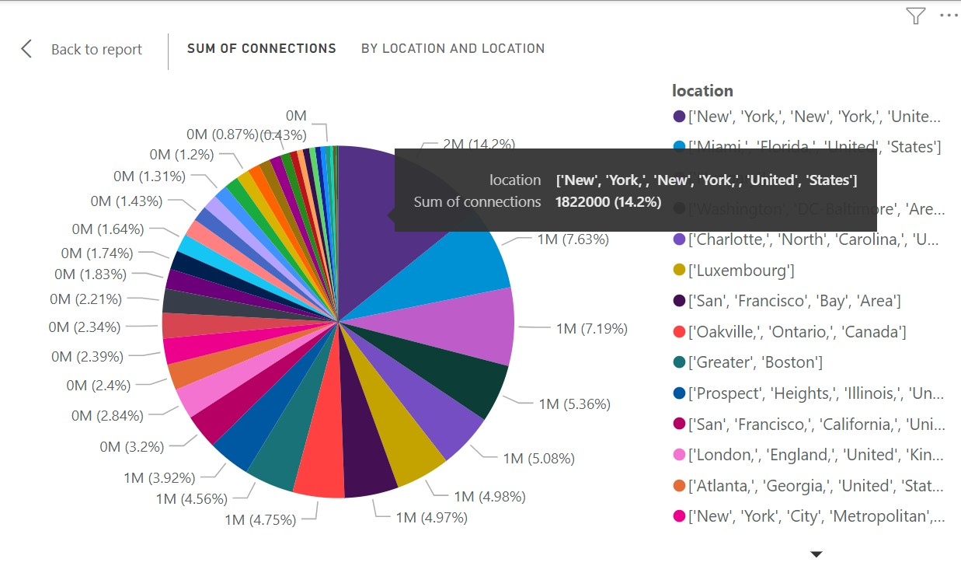

**8. ADVANTAGES & DISADVANTAGES**

**Advantages:**

* + - Professional Insights: The project can provide valuable insights into the world of professional networking, helping users understand what makes certain individuals influential on LinkedIn and how they can improve their own presence.
    - Improved Networking: Users can benefit from personalized content recommendations and more effective networking, helping them make meaningful connections with professionals in their field.
    - Data-Driven Decisions: The project enables data-driven decision-making by offering data-backed insights and recommendations for content creation and networking strategies.
    - Career Opportunities: Understanding what employers or recruiters look for in profiles and the skills and experiences that are in demand can benefit job seekers and professionals looking to advance in their careers.
    - Platform Enhancements: The findings can inform LinkedIn's platform improvements, enhancing user experience and engagement.
    - Ethical Data Usage: By respecting privacy and ethical data usage, the project contributes to responsible data analysis and privacy protection.

**Disadvantages:**

* + - * Data Privacy Concerns: LinkedIn users' data privacy is a significant concern, and data scraping and analysis must be conducted responsibly to avoid privacy violations.
      * Data Collection Challenges: Gathering accurate, complete, and up-to-date data from LinkedIn may be challenging due to restrictions imposed by LinkedIn's API and web scraping limitations.
      * Bias and Fairness: The analysis may introduce biases or ethical concerns, such as favoring certain industries, demographics, or users, if not carefully controlled.
      * Limited Scope: The project may have limitations due to the available dataset, and the findings may not be universally applicable to all LinkedIn users.
      * Platform Changes: LinkedIn's policies and algorithms can change over time, affecting the relevance of the project's findings.
      * Resource Intensive: Data analysis, machine learning, and recommendation systems can be computationally intensive and require significant computational resources.
      * User Engagement: Achieving high user engagement with recommendations or insights can be challenging, as user behavior on the platform may vary.
      * Legal and Ethical Risks: Non-compliance with LinkedIn's terms of service or data privacy regulations can lead to legal and ethical risks.

In conclusion, the "LinkedIn Influencers Data Analysis" project has provided valuable insights into the world of LinkedIn influencers and their impact on the platform. Through a comprehensive examination of influencer profiles, content, follower networks, engagement patterns, and recommendations, we have gained a deeper understanding of the factors that contribute to influence on LinkedIn.

# 9. CONCLUSION

The "LinkedIn Influencers Data Analysis" project has taken us on a journey through the intricate landscape of LinkedIn, unraveling the dynamics of influence, connections, and professional content on this thriving platform. As we conclude this venture, several key takeaways and insights emerge:

* Understanding Influence: We have successfully identified and analyzed the profiles and activities of LinkedIn influencers, shedding light on what sets them apart. Influence on LinkedIn is a complex interplay of skills, experiences, and engaging content that resonates with a specific audience.
* Career Advancement: For LinkedIn users, this project offers a blueprint for career development and networking. By understanding the profiles and engagement patterns of influencers, individuals can strategize their own LinkedIn journeys for better visibility and professional growth.
* Content Strategy: Content creators can harness the insights gained from this analysis to fine-tune their content strategies. By observing the themes and engagement metrics of influential posts, they can craft more compelling and relevant content.
* Data-Driven Decision-Making: We emphasize the importance of data-driven decision-making in the professional realm. Users, businesses, and organizations can now make informed choices, optimize their LinkedIn presence, and forge meaningful connections based on empirical insights.
* Network Expansion: The exploration of LinkedIn influencer networks has opened the doors to potential networking opportunities. Users can connect with like-minded professionals, discover emerging industry trends, and leverage influencer connections for their benefit.
* Recommendation Enhancement: The project highlights the potential for enhancing LinkedIn recommendations, creating a more personalized and engaging experience for users. As we refine our recommendation algorithms and user feedback mechanisms, we inch closer to a more intuitive LinkedIn platform.

# 10. FUTURE SCOPE

The future scope of this research project, extends beyond its immediate objectives. Here are some potential areas for future research and development:

1. **Real-Time Analysis:** Extend the project to provide real-time analysis of LinkedIn data, enabling users to receive up-to-the-minute insights on influencer activities and trending topics. This could be particularly valuable for staying current in rapidly changing industries.
2. **Enhanced Recommendations:** Improve and refine the content and connection recommendation systems. Incorporate machine learning and natural language processing to offer highly personalized and context-aware recommendations.
3. **Influencer Tracking:** Develop a feature that allows users to track specific influencers and receive notifications when they publish new content or make significant updates to their profiles.
4. **Content Generation:** Create an AI-powered content generation tool that helps users create posts and articles optimized for engagement and influence, based on the analysis of successful content.
5. **Interactive Visualization:** Develop interactive data visualizations and dashboards for users to explore LinkedIn trends, influence networks, and content engagement patterns. This would make the insights more accessible and actionable.
6. **Influence Metric Calculation:** Implement influence metrics for LinkedIn users, similar to Klout scores for Twitter. These metrics can help users gauge their own influence and understand how to improve it.
7. **API Integration:** Collaborate with LinkedIn or create an API for users and businesses to access real-time data and recommendations for their profiles and pages.
8. **Education and Training:** Develop educational resources and training programs based on the project's insights. These resources can help LinkedIn users enhance their presence and influence on the platform.
9. **Industry and Company Analysis:** Expand the analysis to include industry-specific insights and company-specific trends. This can benefit businesses looking to understand and tap into sector-specific networks and audiences.
10. **Mobile App:** Create a mobile app that provides on-the-go access to LinkedIn insights and recommendations, making it more convenient for users to leverage the project's findings.
11. **User Feedback Loop:** Establish a feedback loop where users can actively contribute to the project by providing input and data, further improving the analysis and recommendations.
12. **Research Collaboration:** Collaborate with academic institutions and research organizations to conduct in-depth studies on LinkedIn influence, potentially contributing to the academic community's understanding of professional networks.
13. **Privacy and Data Protection Features:** Enhance privacy and data protection features to ensure that user data is handled securely and in compliance with evolving privacy regulations.

The future scope for this project is dynamic, as LinkedIn and the professional networking landscape continue to evolve. The project's adaptability to emerging technologies, changing user behaviors, and platform updates will be key to its ongoing success and relevance.